Thank you again
We look forward to seeing you soon!
Helping our clients achieve their financial goals is our passion. Every client has different needs, expectations and desires. We help them attain those dreams with traditional and alternative methods that suit each and every individual.

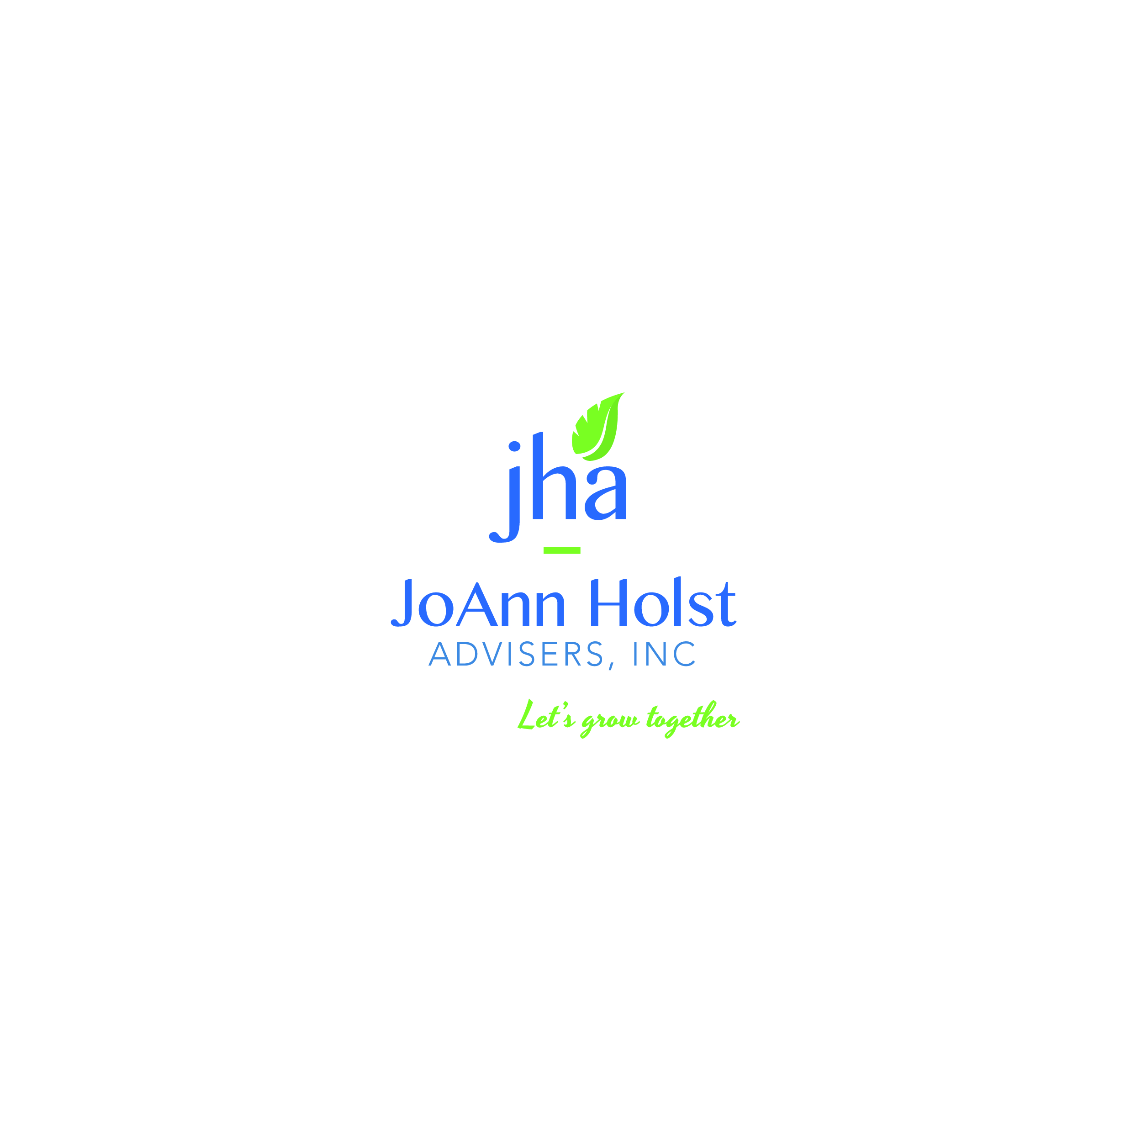



We are looking forward to getting together with you. If you have any questions or require special assistance prior to your visit, please call our office at 720-287-5880.
The following items would be helpful but are optional to bring to our visit:
- Brokerage firm statements
- Life insurance & annuity policies
- IRA & retirement statements
- Social Security statement
- Latest Tax Return
Jo-Ann Holst Advisers
550 S Wadsworth Blvd, Ste 401
Lakewood, CO 80226
720-287-5880

www.joannholstadvisers.com

Financial Planning Confidential Questionnaire

Home#: ( )

Please fill out as much of this form as is relevant for your meeting.
BASIC INFORMATION
Name: Date of Birth:

Retired? Yes No Semi

Spouse Name: Date of Birth:

Retired? Yes No Semi

Primary Address
Street/City/State/Zip
Cell#: ( ) Email:

What is a ball-park figure for your investible assets?

Were you referred to us? Yes No If so, by whom?

CASH FLOW | Please list monthly income from each source:  Husband Wife  Pension Social Security Wages Other Income Are these amounts net or gross? Gross Net  How much are your monthly expenses? | Cash flow questions:  Is your current cash flow sufficient and comfortable? | Yes No
CASH FLOW |  | Do you live off interest your investment dollars earn? | Yes No Don’t Know
CASH FLOW |  | Do you anticipate any significant changes in cash flow? | Yes No Don’t Know
CASH FLOW |  | Are you planning any major lifestyle changes? | Yes No Don’t Know
CASH FLOW |  | Do you foresee any large purchases greater than $5,000 within the next 3 years? | Yes No Don’t Know
CASH FLOW |  | Do you contribute to charity? | Yes No

Home Value $
Autos and Personal Property $
Add’l Liabilities
Balance Owed
Pay off date
/ $ /
Which of the following are your top three concerns?
Losing too much money in the stock market Avoid paying too much in taxes
Considering retirement and not sure if I/we can afford to
Not having a reliable income plan for retirement

Outliving nest egg
Uncertainty about stock market
Leaving a legacy to children and/or grandchildren
Need direction with 401K and/or IRA accounts
Concerned about giving away life savings due to a catastrophic illness
CONCERNS
ASSETS
LIFE EVENTS
OBJECTIVES
In the near future I expect to: (Please check all that apply)
Buy a home Care for a parent Help fund education costs for a family member Sell a home Start/Expand a business Sell a property
Improve a home Pay off debt Receive an inheritance Retire Start a part-time job Purchase a property
Other
(Optional) Assets: Please check off the accounts you currently hold and list the values
Bank / Credit Union Accounts $ Mutual Funds / Stocks / Bonds $ Brokerage Accounts $
Work Retirement Accounts $ CDs $
Business Interest $
(Optional) Property:
Annuities $
IRAs / 401K / 401B / Keoghs / TSAs $ Life Insurance $
Long Term Care Insurance $
Promissory Notes / Contract for Deed $
Other Assets $
(Optional) Liabilities: Mortgage $

Rental/Add’l Properties $ / $ /

More information:
If you are not already retired, when do you want to retire?

How did you acquire your wealth?

How involved would you like to be with your investments?

What is most important about your money to you?

Are you more concerned about growing your assets or protecting what you already have?

MORE INFORMATION

Which of the following describes your risk tolerance when it comes to retirement assets?
Conservative Moderate Aggressive
What are your Financial Objectives? (Check all that apply)
Income Now Guarantees Provided Growth Potential
Tax-Deferred Growth Pass Assets to Beneficiaries Other

BELMAR OFFICE

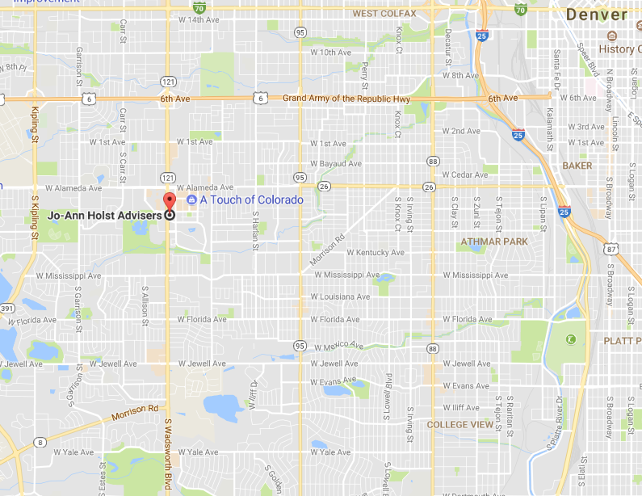

JO-ANN HOLST ADVISERS
550 S Wadsworth Blvd, Ste 401
Lakewood CO 80226
720-287-5880
www.joannholstadvisers.com

